Application Design Document

Index Page no

**Overview 2**

**System Design Overview 2**

**UML Diagram 3**

**Test Case & To run 4 & 5**

* Bijay Sharma

bijays.nitdgp@gmail.com

1. **Overview (Requirement Analysis):**  In this small project, we are aiming to build an application written in Kotlin on Android which takes inputs (First Name, Last Name, Street, State, City, Zip) from a screen. The requirement also includes to auto populate the Address field of the user. First and Last number are provided by the user. The entire information is then bundled in a JSON Object to be sent to a web service. We do not need to write code to send the Jason object.
2. **Design:** There are following steps needed for design. This is an overall design.
3. We make a form with all fields (First Name, Last Name, Street, State, City, Zip).
4. We populate address fields automatically. For this we first use BroadcastReciever’s onReceive method to find the latitude and longitude and then we use geocoder on these coordinates to get the address.
5. If all the fields are filled and valid, we allow the form data to be submitted with **Submit method.**

The application consists of three Kotlin classes.

1. MainActivity
2. GoogleService
3. Validation

**Main Activity**: This is the main class for our android application. It handles the Layout and user input. It also handles the form validation with the help of Validation class and gets the location with the help of Google Service.

It first does following

1. Sets the layout
2. Assign all the input fields to respective variables.
3. Get the geocoder instance:

The overridden onStart() method invokes the GoogleService class.

**GoogleService**: GoogleService uses GPS_Provider provided location. It first checks if NETWORK_PROVIDER and GPS_SERVICE providers are enabled. If they are then it returns the current latitude and longitude else it throws default address of California.

The main activity has several other functions to check permission and request user permission to get the user location.

The method is checkValidation() which actually validate form with the help of validation method.

On pressing the submit button, the form is first validated again form fields and then on successful submission, it prepares a Json object and send it to the webservice.

**Validation:** The validation class has separate method to validate first Name and last name.

Use case Diagram

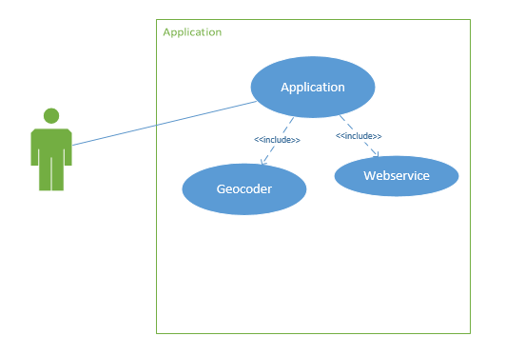

UML Class Diagram

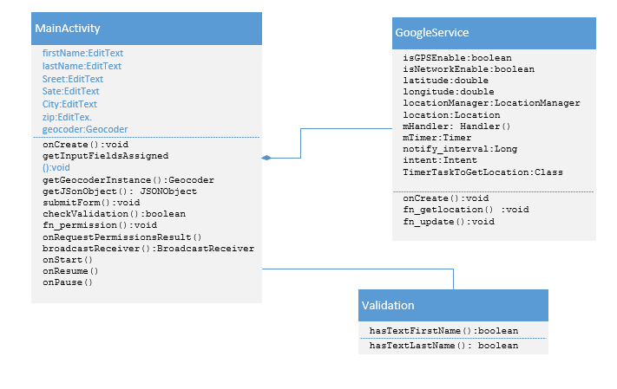

**Test case**

**Blank First Name: Blank Second Name (Tested at different location)**

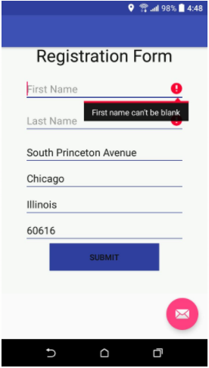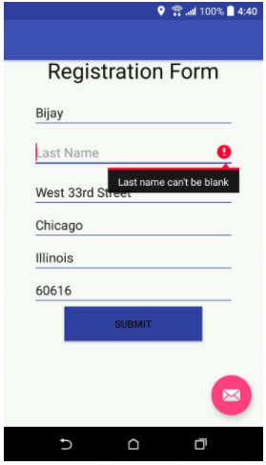

**On pressing submit button**

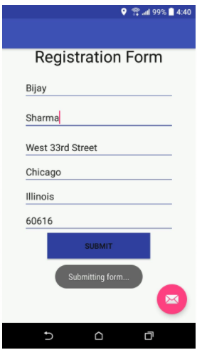

**Run: Built Version: 26.0.1**

**Target Version: 23**

**Run the apk file provided in the zip folder. The app will be installed and ready to use.**